**Ciconia Commercial in confidence**

Ciconia's Vision

To open **low altitude skies for dense aerial operations** of drones and manned aircrafts operating safely and **simultaneously**.

Overview

Billions of dollars have been invested in developing UAS (Unmanned Aerial Systems) in the last few years.  Sophisticated drones have been already fielded, whether its fire fighters’ drones, delivery drones, inspection and monitoring drones or military drones.  Additional billions of dollars have been invested in air taxies to enable efficient transportation in traffic jammed cities and to integrate uncrewed air vehicles into the airspace. **Drones are now safer and easy to operate and are ready to be fielded on a much bigger scale.**

The demand for low altitude airspace is growing. However, **there is no dense drone’s operations. The clear limiting factor is the lack of a DAA (Detect and Avoid) system to prevent midair collision** in dense aerial traffic of drones and crewed airplanes.

Ciconia's flight tested **C&CAS** (Coordination & Collision Avoidance System) **will prevent midair collision between** all kinds of aerial platforms including helicopters, light planes and UAS operating in dense skies.  **The C&CAS will open the bottle-neck**, enabling dense airspace activity of uncrewed and crewed air platforms, operating in close proximity simultaneously.

The BIRD foundation awarded Ciconia with a grant of USD 500,000, Ciconia raised additional USD 700,000.

Competitive Advantages and Key Competitive Highlights

* Ciconia has a team with vast experience in aviation technologies and operations. The **C&CAS** allows first responders to fly airplanes, drones and helicopters safely, in close proximity, in a confined area, even when visibility is limited
* The **C&CAS** secures collision free operations of commercial drones while reducing safety buffers. Thus numerous drones can operate simultaneously in a specific airspace
* Ciconia's **C&CAS** is the only technology of its kind to have performed successfully under intense simulations and flight tests, conducted by the IAF FTC (Israeli Air Force Flight Test Centre) while all others failed (confirmed by an IAF testimonial letter). The **C&CAS** was selected by MAFAT (the Israeli [Defense Advanced Research Projects Agency](https://www.darpa.mil/) – "DARPA") to be the best system to manage mid-air conflicts in low altitude airspace.

Ciconia's technology and systems are:

* Flight test proven
* Applicable for first responders, commercial and military applications
* Ciconia's market size is expected to grow to several billion dollars in the next few years
* Ciconia is working with police departments in the USA to install the **C&CAS** onboard their aerial fleet, to increase flight safety and reduce their operating costs
* The C&CAS software is protected by 2 patents (one granted and one pending approval)
* Ciconia is a member in the RTCA, ASTM and other FAA/NASA working groups aimed at UAS integration into the NAS (National Air Space)

Next two years:

* Ready for full scale production & sales of the first responders’ **C&CAS** application
* Large scale pilot program with a leading delivery company
* Pilot programs with fire departments in the US and Israel
* Large scale pilot by the Israeli Ministry of Defense onboard IAF helicopters & Israeli ground forces’ UASs

A highly professional, dedicated, ambitious team has invested 16 man-years in the C&CAS:

* CEO: Moshe Cohen, Col. (ret) former IAF Cobra & Apache squadrons commander, 20 years of industry management
* VP BD: Gil Yannai, Lt. Col. (ret) former IAF Flight Test Center Commander, 787 airline captain, 15 years industry
* CTO: Ilan Zohar, PhD, Lt. Col. (ret) former IDF elite technology unit commander. Electrical engineer and drone’s expert
* Software: Misha Poyarkov, senior software architecture engineer
* Algorithm & Flight tests: Eran Bar-on, Lt. Col. (ret) IAF Experimental Test Pilot, flight tests manager and algorithm expert
* 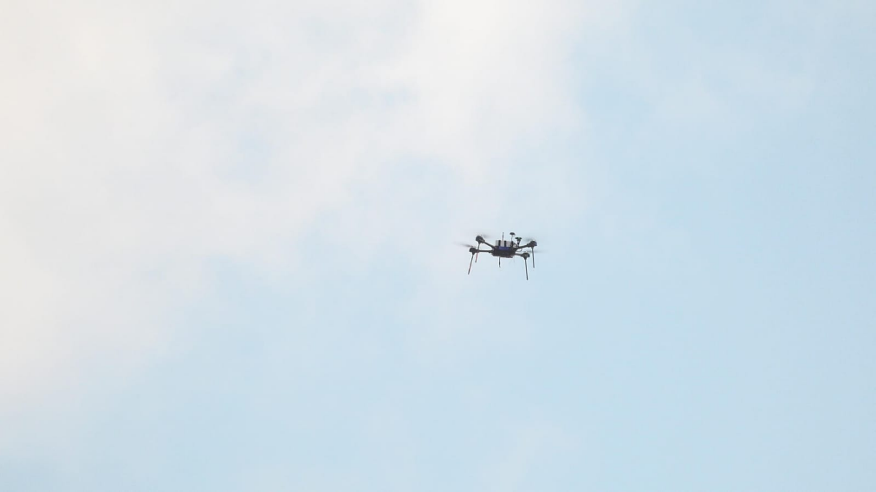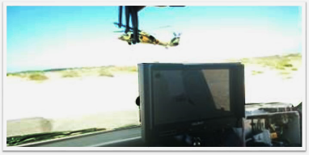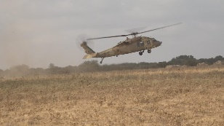Ronen Stoffman, aeronautical & computer science engineer, IAF Flight Test Engineer, system engineer

C&CAS flight test onboard an Israeli Air Force Blackhawk & a drone, July 2021 flight test

C&CAS flight test onboard

an IAF Blackhawk

An IAF pilot tests the

C&CAS on IAF simulator